Artificial Intelligence (AI) and Intelligent Character Recognition (ICR) for Manual Form Data Processing

CHAPTER ONE
INTRODUCTION

Background of the Study
Despite sustained advances in digital information systems, paper-based forms remain a persistent component of data collection workflows in many organizational contexts (Baviskar et al., 2021; Sinha & S, 2025). Questionnaires, administrative forms, and structured surveys are still widely used for capturing information that is later required in digital form for storage, analysis, or reporting. The continued use of paper is often driven by practical considerations such as ease of deployment, familiarity for respondents, regulatory requirements, and the reliability of paper workflows in environments where digital infrastructure is constrained.
The reliance on paper introduces a critical processing challenge once data collection is complete. Information recorded on physical forms must be converted into structured digital representations before it can be integrated into databases or analytical systems. In practice, this conversion is frequently performed through manual data entry, a process that is time-intensive, costly, and prone to transcription errors (Larsson & Segerås, 2016). Even when careful procedures are followed, human data entry introduces variability and inaccuracies that can propagate through downstream systems.
Automated document processing technologies have been developed to address this gap, with Optical Character Recognition serving as the foundational technique for converting visual text into machine-readable data (Sinha & S, 2025). While OCR performs reliably on clean, machine-printed documents, its effectiveness decreases substantially when applied to structured forms that contain handwritten responses, checkboxes, and mixed content (Abdallah et al., 2024; A. Agrawal et al., 2024). Form processing introduces additional complexity beyond character recognition, including the need to identify field boundaries, distinguish static template elements from user-provided input, and handle variations introduced during scanning.
Recent developments in computer vision and artificial intelligence have expanded the range of techniques available for document analysis. These approaches increasingly emphasize structural understanding of documents rather than isolated text recognition. One such perspective treats a completed form not as an independent image to be interpreted in full, but as a modified instance of a known baseline template (Behl & Manisha, 2022). From this viewpoint, the task of form processing becomes one of identifying and interpreting deviations between a blank form and its filled counterpart.
This differential perspective offers a pragmatic way to reduce the complexity of form understanding, particularly for standardized paper forms where layout consistency can be assumed (Shuvo et al., 2022). By focusing on visual differences introduced by user input, the system can isolate relevant regions for further analysis while ignoring static content. This approach aligns naturally with computer vision methods such as image alignment, subtraction, and region-based analysis, which are well suited to scanned document inputs.
However, even with improved automation, fully eliminating errors in form processing remains difficult, due, in part to the ambiguity of handwritten text but also due to variability in the quality, orientation and positioning of the analyzed material (Alaei et al., 2024). As a result, recent research increasingly explores hybrid processing models that combine automated extraction with targeted human validation (Wu et al., 2022). Human-in-the-loop frameworks aim to preserve efficiency while ensuring accuracy by routing uncertain cases for manual review rather than attempting full automation.
Within this context, the present study focuses on the development and evaluation of an automated paper form processing pipeline grounded in differential analysis and confidence-based validation. The work is concerned specifically with scanned paper forms containing printed text, handwritten responses, and checkboxes. The emphasis is placed on reliable extraction, structured output, and measurable performance rather than broad claims of universal applicability. This focus establishes a clear conceptual boundary for the research and provides a foundation for the methodological and evaluative discussions that follow.

1.2 Problem Statement
Paper-based forms remain widely used for structured data collection, yet converting completed forms into reliable digital records continues to present practical challenges. Forms frequently contain a mixture of printed text, handwritten entries, and selection elements such as checkboxes, all of which complicate automated processing (Abdallah et al., 2024; A. Agrawal et al., 2024). When such documents are scanned, variations introduced by handwriting, scanning noise, and alignment distortions further reduce extraction reliability.
Optical Character Recognition systems are commonly used to convert scanned documents into machine-readable text; however, they are primarily designed for continuous text recognition rather than structured form processing (Abdallah et al., 2024). In form-based documents, errors arise not only from character misrecognition but also from difficulties in isolating user-provided input from static template content. As a result, automated extraction often produces incomplete or inaccurate outputs, requiring extensive manual verification.
Many existing form processing solutions treat extraction as a final step rather than a process that requires systematic validation. Confidence measures and error detection mechanisms are often insufficiently integrated, leading either to unchecked automated errors or to inefficient full manual review (Bachinger et al., 2024). This lack of structured validation limits the practical reliability of OCR-based workflows for form-centric documents.
This study addresses the problem of reliable extraction and validation of data from scanned paper forms by investigating a processing pipeline based on differential analysis and selective human intervention. By comparing completed forms against reference templates, the approach aims to isolate user-provided content while reducing sensitivity to static layout elements. The study focuses on evaluating extraction accuracy and validation effectiveness for printed text, handwritten entries, and checkboxes under controlled conditions.

1.3 Aims and Objectives
The aim of this research is to develop an intelligent character recognition (ICR) system for digitising manually completed questionnaires. The specific objectives are to:
- Design a Differential Analysis and Preprocessing for Extraction (DAPE) pipeline that compares scanned completed forms against reference templates to isolate, characterize, and prepare user-provided input regions for extraction.
- Implement the proposed DAPE pipeline by integrating quality-aware preprocessing, template registration, region classification, and targeted OCR/ICR methods for printed text, handwritten input, and checkbox elements.
- Evaluate the effectiveness of the DAPE pipeline by measuring extraction accuracy, confidence-based validation performance, and the impact of selective human-in-the-loop intervention on overall extraction reliability.

Research Questions
RQ1. To what extent can differential analysis between scanned completed forms and reference templates accurately isolate user-provided input regions in structured paper forms?
RQ2. What levels of extraction accuracy can be achieved for printed text, handwritten text, and checkbox fields using the proposed processing pipeline under controlled conditions?
RQ3. How effectively do the implemented validation mechanisms identify unreliable or incorrect extractions within the processed form data?
RQ4. What is the impact of selective human-in-the-loop correction on overall extraction reliability when applied to flagged form fields?

1.4 Significance of the Study
The significance of this study lies in its focused examination of reliable form processing under controlled and well-defined conditions. By addressing the challenges associated with extracting data from scanned paper forms that contain printed text, handwritten entries, and checkbox elements, the work contributes practical insights into the limitations and capabilities of OCR-based processing pipelines.
This study is significant in demonstrating how differential analysis can be applied as a structured mechanism for isolating user-provided content in form-based documents (Behl & Manisha, 2022). Rather than treating completed forms as independent images, the approach emphasizes comparison against reference templates, offering a pragmatic perspective on reducing layout-related ambiguity during extraction. The findings provide evidence on when such an approach is effective and where its limitations arise.
The inclusion of validation mechanisms and selective human-in-the-loop intervention further strengthens the practical relevance of the study. By evaluating system performance before and after manual correction, the work provides measurable insight into the role of targeted human oversight in improving extraction reliability(Imstepf, 2019; Vercruysse et al., 2025). This contributes to a clearer understanding of how automation and human input can be balanced within form processing workflows(Grønsund & Aanestad, 2020).
From an academic perspective, the study offers a structured evaluation framework that links preprocessing, extraction, validation, and correction within a single pipeline as well as the limitations of the approach undertaken. This integration supports clearer analysis of error sources and performance trade-offs in form-based document processing. The results may inform future research that seeks to extend similar approaches to more complex layouts, additional languages, or broader document categories.

1.5 Scope and Limitations

1.5.1 Scope
The development and evaluation of the automated form processing system are conducted within the following defined parameters:
• Processing of scanned paper forms containing machine-printed text, clearly handwritten responses, and checkbox elements on standardized form layouts
• Support for common structured form components including text fields, handwritten input areas, and checkbox selections
• Input documents limited to scanned images generated using flatbed scanners at sufficient resolution, with a minimum of 300 DPI
• Use of predefined blank form templates as reference inputs to support differential analysis between unfilled and completed forms
• Extraction output structured using a defined JSON schema to ensure consistency, traceability, and ease of evaluation
• Accuracy and validation assessment using form datasets with known ground truth values to enable objective performance measurement
• Integration of confidence-based validation mechanisms to identify uncertain or unreliable extractions
• Selective human-in-the-loop correction applied only to flagged documents rather than full manual review
• Evaluation of system performance using batch processing to reflect realistic organizational form handling scenarios

1.5.2 Limitations
While the proposed system addresses key challenges in form-based document processing, several limitations define the boundaries of this study:
• The system does not support poorly scanned, heavily degraded, or physically damaged documents where visual artefacts significantly impair image analysis
• Illegible or highly ambiguous handwritten input that falls below defined confidence thresholds is not automatically interpreted and is instead flagged for manual correction
• Forms with highly irregular or non-standardized layouts require corresponding reference templates and are not processed without prior template definition
• The system is designed for batch processing and does not support real-time or interactive document processing
• Text recognition is limited to English-language documents, and multilingual or non-Latin scripts are not evaluated
• Semantic analysis is limited to support validation and normalization of extracted values. Broader contextual reasoning or document-level semantic interpretation is outside the scope of this study.
• Specialized form elements such as barcodes, complex tabular structures, embedded images, or signature verification are outside the scope of the current implementation

1.6 Definition of Terms
For clarity and consistency, the following terms are used throughout this study with the meanings defined below.
Differential Analysis is a method for identifying user-provided inputs on paper forms by computationally comparing scanned completed documents against corresponding blank reference templates. This comparison is used to detect visual deviations introduced by handwriting, markings, or selections, rather than relying on absolute interpretation of document content.
Optical Character Recognition (OCR) denotes the technology used to convert images of printed or handwritten text into machine-encoded text representations, enabling further digital processing, validation, and storage.
Confidence Scoring is a numerical measure generated by the processing system that represents the estimated reliability of an extracted value. Confidence scores are used to determine whether an extraction can be accepted automatically or should be flagged for manual review.
Human-in-the-Loop (HITL) describes a hybrid validation approach in which extracted values that fall below predefined confidence or validation thresholds are selectively routed for manual correction by a human operator. This approach combines automated processing with targeted human intervention to improve overall reliability.
Structured JSON Output refers to the standardized machine-readable format used to represent extracted form data. Information is organized into consistent key-value pairs, enabling systematic evaluation and facilitating integration with downstream databases or analytical systems.
Template Registration is the process of aligning a scanned form with its corresponding reference template in order to compensate for variations in scanning position, rotation, or scale. Accurate registration ensures reliable comparison during differential analysis.
Field-Type Classification denotes the automated identification of different response elements within a form, such as text fields and checkbox selections. This classification enables the application of appropriate extraction and validation techniques for each element type.
A Preprocessing Pipeline refers to the sequence of automated image enhancement operations applied to scanned documents prior to extraction and analysis. These operations may include de-skewing, noise reduction, and contrast enhancement, and are intended to improve the reliability of subsequent processing stages.

1.7 Theoretical Framework
The core of this research is grounded in differential analysis theory as applied to document processing. Differential analysis is based on the premise that completed forms can be interpreted as modified instances of a known reference structure (Behl & Manisha, 2022; Shuvo et al., 2022). Rather than attempting to interpret form content in isolation, the approach simplifies form recognition by identifying visual deviations introduced by user input when a filled form is compared against a corresponding blank template.
This perspective is conceptually related to the superimposition approach proposed by for handwritten numeral recognition, where a known baseline representation is used to interpret unknown handwritten inputs. In the context of this study, the blank form template functions as the baseline, and handwritten entries, marked selections, and checkbox responses are treated as deliberate visual modifications to that baseline. This allows the form processing task to be reframed as the systematic detection and classification of deviations rather than full document interpretation.
The study also draws upon principles from pattern recognition theory, particularly feature extraction and classification techniques used to distinguish between different visual elements (Lanjewar et al., 2021). These principles inform the design of processing routines tailored to specific field types, such as printed text regions, handwritten input areas, and checkbox elements. Each field type presents distinct visual characteristics and error patterns, requiring differentiated analytical treatment within the pipeline.
The use of confidence scoring and selective human-in-the-loop validation is informed by quality management and reliability-oriented system design principles (V. Agrawal, 2025; Wu et al., 2022). This theoretical perspective acknowledges that automated processing may not achieve uniform reliability across all inputs. Instead, system performance can be improved by identifying uncertain extractions and applying targeted human validation only where necessary. In this framework, human intervention is treated as a controlled corrective mechanism rather than a replacement for automation.
Finally, the overall system design is influenced by software engineering principles of modularity and separation of concerns (V. Agrawal, 2023). The processing pipeline is structured into distinct components, including preprocessing, template registration, differential analysis, extraction, validation, and data structuring. This modular approach supports clarity in evaluation and provides a structured foundation for potential future extensions without altering the core methodology.

1.8 Assumptions
The development and evaluation of the automated form processing system are conducted under the following assumptions:
- High-quality digital templates of blank forms are available for all form types evaluated, providing a reliable reference for differential analysis.
- Scanned form images are of sufficient quality, including adequate resolution, contrast, and minimal distortion, to support computer vision and OCR operations.
- Users complete forms by providing responses within designated fields rather than through marginal annotations or free-form markings.
- Forms maintain consistent layout structures across instances of the same form type, enabling reliable template alignment and field localization.
- Form inputs are completed using standard writing instruments with markings visually distinguishable from pre-printed content.
- Organizational workflows are able to accommodate a hybrid automated and manual validation process in which low-confidence extractions are reviewed selectively.
- The defined accuracy and confidence thresholds represent meaningful quality criteria for evaluating system performance within the intended application context.

1.9 Organization of the Report
This report is structured to present the research in a logical progression from conceptual foundation to implementation and evaluation. The organization follows standard academic conventions for technical research while maintaining clarity and coherence.
Chapter 2 presents a review of relevant literature on automated form processing, OCR technologies, document analysis methods, and validation approaches. The chapter identifies limitations in existing work and situates the present study within the identified research gap.
Chapter 3 describes the research methodology, including the system architecture, processing pipeline, differential analysis approach, validation mechanisms, and evaluation design. The chapter explains the rationale behind key design decisions and outlines the procedures used for system assessment.
Chapter 4 details the implementation of the automated form processing system, covering preprocessing, template registration, extraction, validation, and structured data output components.
Chapter 5 reports the validation results, presenting accuracy measurements, error analysis, and the impact of selective human-in-the-loop intervention across evaluated form datasets.
Chapter 6 concludes the report by summarizing the findings, discussing their implications, acknowledging limitations, and outlining directions for future research and system enhancement.

CHAPTER TWO
SYSTEMATIC LITERATURE REVIEW

2.1 Overview of Automated Document and Form Processing
Automated document processing aims to convert visual representations of documents into structured, machine-readable data suitable for storage, analysis, and integration with digital systems (Baviskar et al., 2021). Within this broad area, form processing represents a more constrained but challenging task due to the presence of predefined layouts combined with user-provided input. Unlike free-flowing documents, forms impose a fixed structural template while allowing variability in how users complete individual fields.
Traditional document processing pipelines typically involve image acquisition, preprocessing, text recognition, and output structuring (Mursari & Wibowo, 2021; Sinha & S, 2025). For form-based documents, additional stages are required to identify field locations, distinguish static content from variable input, and associate extracted values with predefined semantic labels. These requirements introduce complexity beyond standard OCR, particularly when forms contain handwritten responses, checkboxes, or marked selections.
Automated form processing systems can be broadly categorized into template-based and non-template-based approaches. Template-based systems rely on predefined knowledge of form layout to guide extraction, whereas non-template-based systems attempt to infer structure dynamically (Behl & Manisha, 2022). Template-based approaches are commonly applied in controlled environments where form layouts are consistent and known in advance, offering advantages in reliability and interpretability. However, they require accurate alignment between scanned forms and reference templates to function effectively.
Form processing workflows are further complicated by variability introduced during scanning, such as skew, scale differences, and noise (Alaei et al., 2024). These factors can degrade recognition performance and lead to misalignment between detected content and expected field locations. As a result, preprocessing and alignment play a critical role in ensuring that subsequent extraction and validation stages operate reliably.
Within organizational contexts, automated form processing is often evaluated not only on extraction accuracy but also on its ability to reduce manual workload while maintaining acceptable data quality. This has led to increased emphasis on validation mechanisms that identify uncertain outputs and support selective human review rather than full automation.

2.2 Optical Character Recognition in Form-Based Documents
Optical Character Recognition is a foundational component of automated document processing systems, enabling the conversion of visual text into machine-encoded representations (Sinha & S, 2025). OCR technologies have matured significantly and perform well on clean, machine-printed text under controlled conditions. However, their effectiveness is reduced when applied to form-based documents that contain heterogeneous content types and layout-dependent structures.
In form processing scenarios, OCR is typically applied to localized regions corresponding to predefined fields rather than to entire documents (Abdallah et al., 2024). This localized application requires accurate detection of field boundaries and separation of static template text from user-provided input. Errors in field localization or segmentation can propagate through the pipeline, resulting in incorrect or incomplete data extraction even when character recognition itself is accurate.
Handwritten text presents a particular challenge for OCR systems due to variations in writing style, stroke thickness, spacing, and legibility (A. Agrawal et al., 2024; Mursari & Wibowo, 2021). When handwriting appears within structured forms, it often overlaps with printed field labels or boundaries, further complicating recognition. Checkbox elements and marked selections introduce additional non-textual features that standard OCR engines are not designed to interpret directly, requiring supplementary detection and classification methods (Mursari & Wibowo, 2021).
OCR performance is also sensitive to image quality and the effectiveness of the preprocessing phase (Alaei et al., 2024). Scanning artefacts such as skew, uneven illumination, and background noise can significantly affect recognition accuracy. As a result, preprocessing techniques such as de-skewing, noise reduction, and contrast enhancement are commonly employed to improve OCR reliability in form processing pipelines.
While OCR provides the initial text extraction capability, it does not inherently assess the correctness or completeness of extracted values. Confidence measures generated by OCR engines may offer limited insight into reliability, particularly for handwritten content. This limitation motivates the integration of additional validation mechanisms that operate beyond character-level recognition, especially in workflows where data accuracy is critical.

2.3 Image Preprocessing and Template Registration
Image preprocessing is a critical stage in automated form processing pipelines, as the reliability of downstream analysis is directly affected by the quality of input images (Mursari & Wibowo, 2021). Scanned paper forms often exhibit distortions such as skew, uneven illumination, background noise, and variations in scale. These factors can interfere with accurate alignment, segmentation, and text recognition if left unaddressed.
Preprocessing operations are applied to normalize scanned documents prior to extraction and analysis(Mursari & Wibowo, 2021). Common operations include de-skewing to correct rotational misalignment, noise reduction to suppress background artefacts, and contrast enhancement to improve the visibility of text and markings. These operations aim to produce a visually consistent representation of forms that facilitates reliable comparison against reference templates.
Template registration works by aligning a scanned completed form with its corresponding blank template (Lanjewar et al., 2021). Accurate registration is essential in template-based systems, as even minor misalignments can lead to incorrect field localization or false detection of differences. Registration techniques typically account for translation, rotation, and scaling differences between the scanned form and the reference template.
Once registration is achieved, the spatial correspondence between the scanned form and the template enables precise localization of predefined fields. This alignment allows subsequent processing stages to focus exclusively on regions where user input is expected, reducing sensitivity to static layout elements and printed content. Reliable preprocessing and registration therefore form the foundation for differential analysis and field-level extraction.

2.4 Differential Analysis in Form-Based Document Processing
Differential analysis is an approach to form processing that emphasizes the comparison between a completed form and a corresponding blank template to identify user-provided input. Rather than attempting to interpret the entire document content in isolation, the method treats filled forms as modified instances of a known baseline structure (Shuvo et al., 2022).
In this framework, user inputs are conceptualized as deliberate visual deviations from the reference template (Behl & Manisha, 2022). Handwritten text, checkbox markings, and other form responses introduce localized changes that can be detected through image comparison techniques. By isolating these deviations, differential analysis reduces the complexity of form understanding and limits processing to regions of interest.
Differential analysis benefits from the consistent layout structures typical of standardized forms. When reliable template registration is achieved, differences between the filled form and the blank template can be analyzed systematically to extract relevant input content. This approach reduces interference from static printed elements and mitigates the impact of layout variability.
The effectiveness of differential analysis depends on accurate preprocessing, robust alignment, and appropriate handling of noise and scanning artefacts (Alaei et al., 2024). False differences may arise from imperfect registration or image quality issues, necessitating the integration of validation mechanisms to assess the reliability of detected deviations. As a result, differential analysis is most effective when embedded within a broader pipeline that includes confidence assessment and selective human review .

2.5 Validation and Confidence-Based Assessment
Validation plays a critical role in automated form processing by determining whether extracted values can be trusted without further intervention (V. Agrawal, 2025). In form-based workflows, extraction accuracy alone is insufficient, as errors may not be uniformly distributed across fields or content types. Validation mechanisms are therefore used to assess the reliability of extracted data and to identify cases where automated processing may be inadequate.
Confidence-based assessment is a common validation strategy in document processing systems (Hemmer et al., 2024). Confidence scores provide a quantitative indication of the system’s certainty in an extracted value, based on factors such as recognition quality, visual clarity, and consistency with expected formats. In the context of form processing, confidence assessment enables field-level evaluation rather than treating the document as a single unit.
Validation mechanisms may combine multiple signals, including OCR confidence values, consistency checks, and similarity-based comparisons (V. Agrawal, 2025; Vercruysse et al., 2025). For example, extracted text may be evaluated against expected character patterns, known response formats, or reference value sets. When strict matching is insufficient, similarity-based validation can be applied to identify near-equivalent responses while still preserving quality control.
The purpose of validation in this study is not to guarantee correctness but to identify uncertainty. Fields that fail validation checks or fall below predefined confidence thresholds are flagged rather than accepted automatically. This selective identification of unreliable extractions enables targeted intervention while avoiding unnecessary manual review of high-confidence results.
By integrating validation as an explicit stage in the processing pipeline, the system supports more transparent evaluation of performance. Validation outcomes can be analyzed alongside extraction results to identify error patterns, assess reliability across field types, and measure the effectiveness of corrective mechanisms applied later in the workflow.

2.6 Human-in-the-Loop Approaches in Form Processing
Human-in-the-loop approaches are used in automated form processing to address limitations in fully automated extraction, particularly in cases involving ambiguous handwriting, low-quality scans, or visually complex inputs (Mosqueira-Rey et al., 2023). Rather than replacing automation, human involvement is applied selectively to improve overall system reliability while maintaining efficiency.
In form processing workflows, human-in-the-loop validation is typically triggered by automated confidence or validation checks (Imstepf, 2019). Fields identified as uncertain or unreliable are routed for manual review, while high-confidence extractions proceed without intervention. This approach allows human effort to be focused on problematic cases rather than applied uniformly across all processed documents.
The integration of human validation introduces a controlled feedback mechanism within the processing pipeline. Human corrections can resolve errors that automated methods are unable to address reliably, particularly for handwritten text or borderline cases. By limiting manual intervention to flagged fields, the system balances accuracy improvement with operational efficiency (Vercruysse et al., 2025; Wu et al., 2022).
From an evaluation perspective, human-in-the-loop processing enables comparative analysis of system performance before and after intervention (Vercruysse et al., 2025). This comparison provides insight into the contribution of human correction to extraction reliability and supports objective assessment of the trade-offs between automation and manual effort.
In the context of this study, human-in-the-loop intervention is treated as a validation mechanism rather than a primary extraction method. Its role is to complement automated processing by addressing residual uncertainty, reinforcing the reliability of structured outputs without extending the system into fully manual workflows.

2.7 Table of Related Works
S/N | Authors (Year) | Problem Addressed | Methodology | Key Findings | Limitations
1 | Smith (2007) | OCR engine limitations | Analyzed Tesseract architecture including segmentation, classifiers, and layout analysis on scanned documents. | OCR accuracy strongly dependent on preprocessing quality. | Does not address structured forms, validation workflows, or human-assisted error correction mechanisms.
2 | Smith et al. (2009) | Multilingual OCR challenges | Extended Tesseract with adaptive classifiers and language models for multilingual document recognition. | Language models improve recognition accuracy. | Limited evaluation on handwritten text and structured form layouts.
3 | Patel et al. (2012) | OCR in practical workflows | Case study applying Tesseract to real scanned documents in operational settings. | OCR viable but error-prone in practice. | Lacks systematic validation framework and confidence-based evaluation.
4 | Björkman (2021) | Preprocessing impact on OCR | Compared binarization, denoising, and contrast enhancement techniques before OCR execution. | Preprocessing significantly improves OCR results. | Focused only on text recognition, not form-level extraction.
5 | Sporici et al. (2020) | OCR accuracy improvement | Applied convolution-based preprocessing prior to Tesseract OCR. | Demonstrated measurable accuracy gains. | Requires careful parameter tuning and increased computational cost.
6 | Pangestu et al. (2017) | OCR noise sensitivity | Used histogram equalization and normalization before OCR processing. | Improved recognition in noisy scans. | Evaluated on limited document types and layouts.
7 | Mahawan & Udayana (2020) | OCR preprocessing effectiveness | Applied median and average filtering for scanned document OCR. | Noise reduction improved OCR accuracy. | No analysis of handwritten text or structured fields.
8 | Mursari & Wibowo (2021) | Handwritten OCR accuracy | Combined grayscale conversion, morphology, and filtering with Tesseract OCR. | Accuracy increased substantially after preprocessing. | Dataset size small and limited handwriting variability.
9 | Li et al. (2016) | Handwritten OCR challenges | Applied morphological operations and resizing for handwritten character recognition. | Improved character-level accuracy. | Language-specific and not generalizable to form processing.
10 | Kumar et al. (2011) | Script-specific OCR | Designed preprocessing and segmentation for Indian scripts. | Improved OCR accuracy for complex scripts. | Not applicable to English-language structured forms.
11 | Rakshit & Basu (2008) | Roman handwriting recognition | Used segmentation and OCR-based classification for handwritten characters. | Moderate recognition accuracy achieved. | Does not scale to full documents or forms.
12 | Abdul Robby et al. (2019) | OCR for non-Latin scripts | Integrated script-specific preprocessing with Tesseract OCR. | Improved recognition for non-Latin text. | Requires language-specific tuning and models.
13 | Koistinen et al. (2020) | Historical document OCR | Iterative OCR evaluation with manual correction loops. | OCR errors reduced through iteration. | High manual effort and no automated confidence thresholds.
14 | Kissos & Dershowitz (2016) | OCR error correction | Applied feature-based word classification after OCR output. | Post-processing reduces OCR errors. | Operates after OCR, not integrated into extraction pipeline.
15 | Promin & Suriyachai (2019) | Medical document digitization | Combined OCR with manual verification for sensitive documents. | Hybrid approach improved reliability. | Domain-specific and not scalable without high manual effort.
16 | Shuvo et al. (2022) | Handwritten digit recognition | Used superimposition of handwritten input over printed baselines. | Baseline comparison simplifies recognition. | Limited to digit recognition, not full forms.
17 | Agarwal et al. (2019) | Form OCR robustness | Template-based OCR with predefined field localization. | Improved accuracy for structured forms. | Template rigidity limits adaptability to layout changes.
18 | Form Understanding Survey (2020) | Form processing techniques | Reviewed template-based and learning-based form understanding methods. | Templates effective for structured documents. | Survey lacks experimental validation or system implementation.
19 | Document Understanding Framework (2021) | End-to-end document AI | Proposed modular architecture for document processing pipelines. | Modular design improves extensibility. | Framework-level discussion without empirical evaluation.
20 | Automated Invoice Handling (2020) | Invoice extraction | Combined OCR, layout analysis, and rule-based validation. | High accuracy for controlled invoices. | Highly domain-specific and template-dependent.
21 | HITL Climate Data Study (2021) | HITL data extraction | Applied confidence-triggered human validation to OCR outputs. | Reduced critical extraction errors. | Increased processing time due to manual review.
22 | OCR Error Correction Survey (2018) | OCR limitations | Surveyed post-recognition correction techniques. | OCR alone insufficient for high accuracy. | Does not address real-time or integrated pipelines.
23 | Image Quality Assessment Survey (2020) | Scan quality impact | Reviewed degradation effects on document recognition systems. | Poor quality strongly degrades OCR accuracy. | Does not propose extraction or validation methods.
24 | OCR in Healthcare (2019) | Sensitive document processing | Designed accuracy-focused OCR pipelines for healthcare documents. | Validation critical in high-risk domains. | Limited generalization beyond healthcare forms.
25 | Digitization Survey (2018) | Document digitization challenges | Reviewed OCR-based digitization approaches. | Structured documents easier to digitize. | High-level review without system-level detail.
26 | Handwritten Recognition Survey (2017) | Handwriting OCR methods | Surveyed classical and ML-based handwriting recognition techniques. | Handwriting remains challenging. | Focused on recognition, not form processing.
27 | Salehudin et al. (2023) | Evaluation of OCR robustness under image degradation conditions. | Controlled experiments using EasyOCR on Latin characters with varying intensity contrast, Gaussian blur, and character size. | OCR confidence decreases with increased degradation; character size and blur significantly affect recognition reliability. | Limited to single-character Latin dataset; no word-level context, real documents, or downstream error detection.
28 | Hemmer et al. (2024) | Detection of OCR transcription errors using confidence-aware post-OCR processing. | Integration of OCR confidence scores into a BERT-based error detection model (ConfBERT), evaluated across multiple OCR engines and datasets. | Incorporating confidence metrics improves OCR error detection performance, especially for well-calibrated OCR systems. | Focuses on error detection rather than correction; performance depends on OCR confidence calibration quality.

2.8 Research Gap Summary
Despite advances in OCR, template-based extraction, and HITL validation, existing approaches either rely on heavy learning-based models or treat validation as an afterthought. There is limited work that integrates differential template comparison with confidence-driven HITL validation in a modular, evaluation-focused pipeline.

CHAPTER THREE
METHODOLOGY
This chapter describes the research design, system architecture, implementation approach, dataset construction, and evaluation procedures used to develop and validate the proposed automated form processing system. The chapter emphasizes methodological clarity, reproducibility, and alignment with the study’s defined scope and objectives.

3.1 Research Design
This study adopts a design science research methodology focused on the development and evaluation of a functional software artifact (V. Agrawal, 2023). This study proposes a Differential Analysis and Preprocessing for Extraction (DAPE) pipeline designed to isolate, extract, and validate user-provided inputs from scanned form documents. The research follows an iterative build–evaluate–refine cycle, where system components are implemented, tested against objective criteria, and refined based on observed outcomes. The principal outcome of the study is a validated prototype demonstrating the feasibility of the proposed approach under controlled conditions.

3.2 System Design and DAPE Pipeline Architecture
The proposed system is designed as a modular, sequential processing pipeline in which scanned completed forms are processed as modified instances of known reference templates. Blank templates provide structural baselines, allowing static layout elements to be separated from user-provided inputs through controlled comparison. The system architecture combines clearly defined functional modules with a strictly sequential execution model, ensuring that each processing stage consumes the outputs of the preceding stage.
At a high level, the system comprises modules for preprocessing, template alignment, differential analysis, field extraction, validation, and structured data output. Each module performs a single, well-defined role and communicates with adjacent modules through explicit inputs and outputs. This modular separation supports independent testing, controlled evaluation, and future modification without altering the overall processing flow. The end-to-end execution of the system proceeds deterministically from document ingestion to validated data export.
The overall system architecture is illustrated in the system architecture diagram:
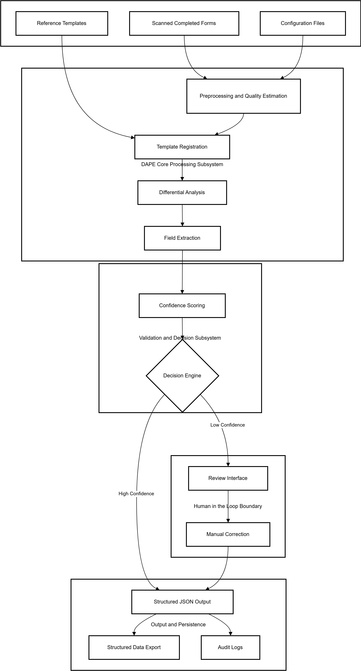
Figure 3.1: DAPE system architecture

3.2.1 Preprocessing Pipeline
The preprocessing stage is responsible for normalizing scanned input images to reduce variability introduced during document acquisition. As the diagram shows, scanned images undergo grayscale conversion followed by intensity and noise estimation. Blur and noise characteristics are assessed to guide subsequent normalization steps. Skew estimation and correction are applied to address minor rotational misalignment, after which illumination normalization and adaptive binarization are performed to enhance foreground content. Border removal and final refinements produce a standardized preprocessed image suitable for downstream alignment and analysis. This pipeline ensures that variations in scan quality do not propagate into later stages of the system.
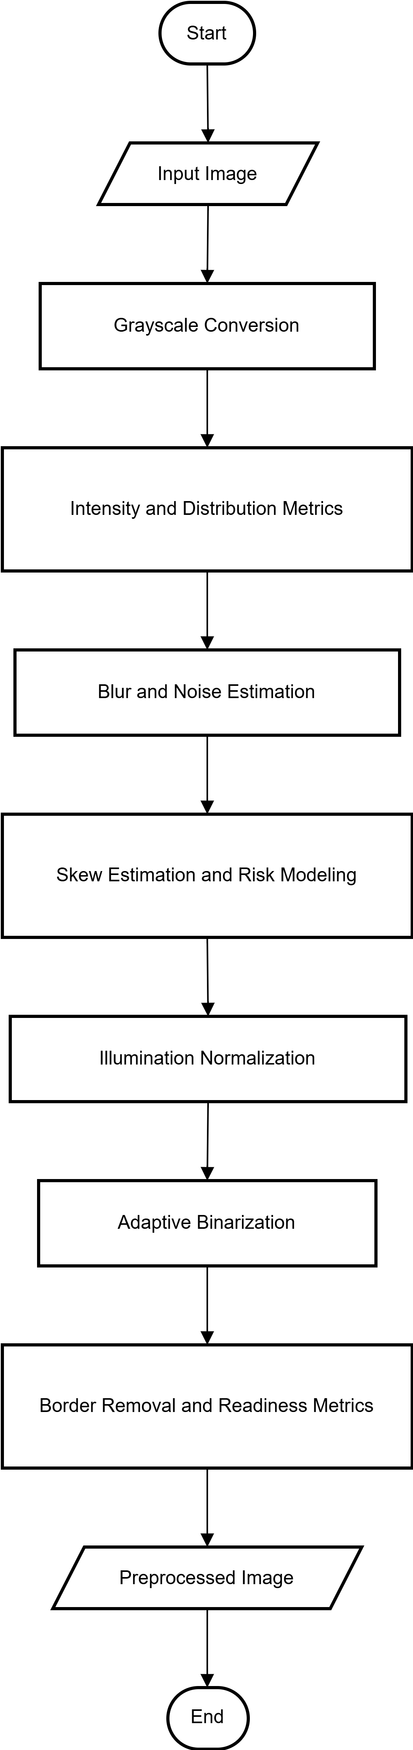
Figure 3.2: Document preprocessing pipeline

3.2.2 Template Alignment and Differential Extraction Pipeline
Following preprocessing, each completed form is aligned with its corresponding blank template to establish pixel-level correspondence. As portrayed by the diagram, alignment corrects translation, scale, and rotation differences introduced during scanning. Once aligned, pixel-wise difference computation is performed between the completed form and the template to identify regions of deviation corresponding to user-provided inputs.
Morphological cleanup operations are applied to the resulting difference map to suppress noise and consolidate meaningful regions. The cleaned output is converted into an input region mask, which guides field isolation. Field-level extraction is then performed, separating text fields and checkbox regions for subsequent processing. This stage concludes with the generation of raw extracted field data.
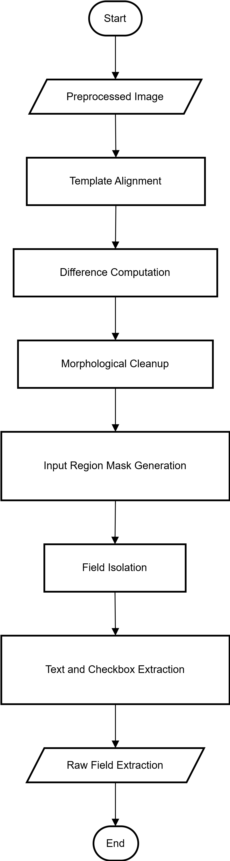
Figure 3.3: Differential analysis and extraction pipeline

3.2.3 Confidence-Based Validation and Human-in-the-Loop Escalation
Extracted fields are subjected to confidence assessment and validation logic. As illustrated in the human-in-the-loop escalation flowchart, each field is assigned a confidence score based on extraction characteristics. A decision stage evaluates whether the confidence exceeds predefined acceptance thresholds.Fields with high confidence are automatically accepted, while low-confidence fields are flagged for manual review. Flagged fields are presented to a human operator through a validation interface, where corrections or confirmations can be applied. Regardless of the validation path, all fields converge into a validated output state. This mechanism allows for selective human intervention without altering system parameters or processing logic.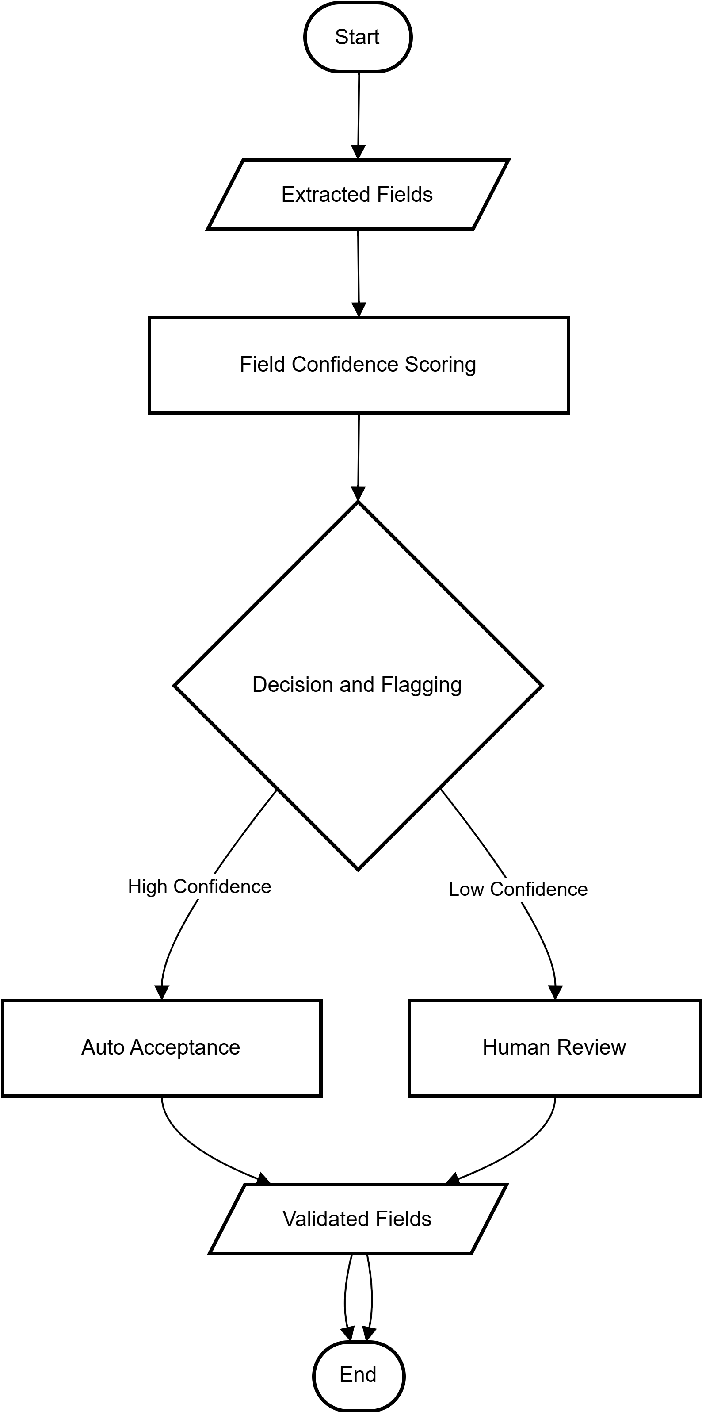
Figure 3.4: Confidence-based validation and HITL flow

3.2.4 Output Structuring and Data Export Pipeline
Validated fields are passed into the output pipeline, as shown in the data export diagram. Field values are first mapped to predefined semantic keys to enforce consistency. The mapped data is then structured into a standardized JSON representation. An auxiliary conversion stage supports transformation of the structured output into alternative formats such as CSV and XLSX. An audit log is generated to record processing outcomes, after which the data export process is completed.
This stage defines the final system output and ensures compatibility with downstream data analysis and storage systems.
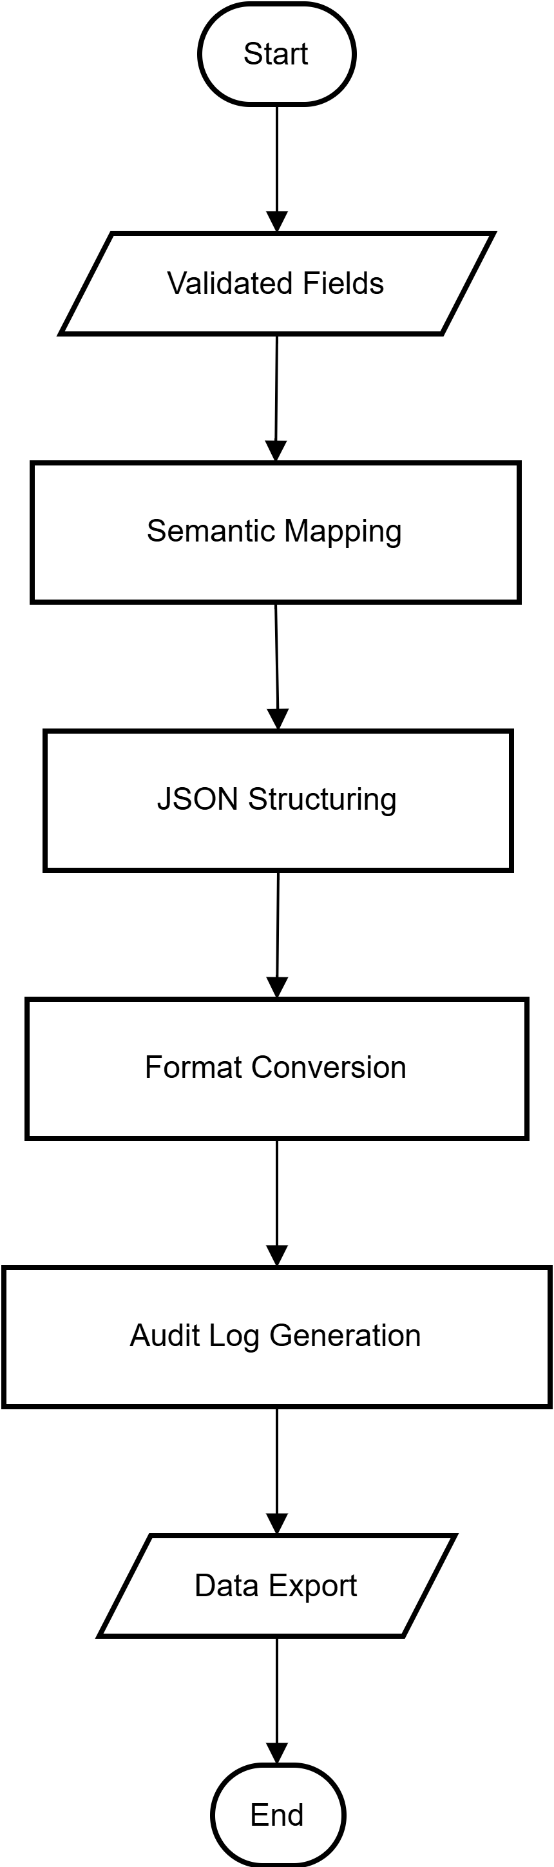
Figure 3.5: Structured output and export flow
From a software design perspective, the system is implemented using a modular object-oriented structure. Core classes encapsulate responsibilities such as image preprocessing, template management, differential analysis, field extraction, confidence scoring, validation control, and data export. Relationships between classes reflect data dependencies and execution order rather than tight coupling, supporting maintainability and reproducibility.
The internal software structure and class relationships are presented in the class diagram:
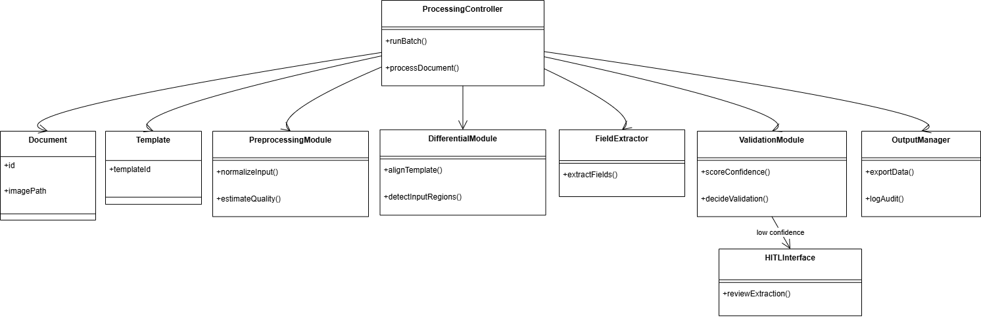
Figure 3.6: UML class diagram of the system

Together, these design components specify the structural organization, execution sequence, and module-level responsibilities of the DAPE pipeline.

3.3 Data Collection
A custom dataset was created specifically for this study to enable controlled evaluation of system performance. Blank templates of standardized forms were printed, manually completed using varied handwriting styles and marking patterns, and scanned at a resolution of 300 DPI using a flatbed scanner. All input documents are scanned images rather than photographs to ensure consistency across samples.
The evaluation dataset consists of 45 completed forms representing three distinct form templates, with 15 instances per template. For each completed form, a corresponding ground truth data file was manually created to serve as the reference for accuracy assessment.

3.4 System Implementation Methodology
The DAPE pipeline is implemented entirely in Python and integrates classical computer vision techniques with OCR-based extraction and rule-driven validation logic. All scanned documents undergo a preprocessing pipeline implemented using OpenCV to normalize image quality and reduce variability introduced during scanning. Preprocessing steps include grayscale conversion, noise reduction using Gaussian filtering, adaptive threshold-based binarization, and deskewing to correct minor rotational misalignment.
Each scanned completed form is aligned with its corresponding blank template using affine transformations to correct translation, scale, and rotation differences introduced during acquisition. Accurate alignment ensures pixel-level correspondence between the completed form and the reference template, which is required for reliable differential analysis.
Differential analysis is performed by computing pixel-wise differences between the aligned completed form and the blank template. Regions exhibiting significant deviation are interpreted as user-provided inputs. Morphological operations are applied to suppress noise and consolidate meaningful regions into a binary mask representing detected interaction areas.
Field localization is guided by predefined coordinates associated with each form template. Text fields are extracted and processed using the Tesseract OCR engine, configured to support both printed and handwritten text recognition. Checkbox and selection fields are evaluated by computing pixel density within defined field regions, with predefined thresholds used to classify fields as marked or unmarked.
Each extracted field is assigned a confidence score. OCR-derived fields use confidence values provided by the recognition engine, while checkbox confidence is derived from deviation magnitude relative to the marking threshold. Extracted values are further evaluated using semantic validation rules that enforce formatting constraints, logical consistency, and field-specific expectations. Fields that fall below predefined confidence or validation thresholds are flagged for manual review through a web-based human-in-the-loop interface. Human corrections update the final output but do not alter system parameters or processing logic.
Validated field values are mapped to predefined semantic keys and assembled into structured JSON objects. An auxiliary module converts the structured output into additional formats such as CSV and XLSX for compatibility with common data analysis tools.

3.5 Evaluation Metrics and Performance Analysis
System performance is evaluated by comparing extracted outputs with ground truth values on a field-by-field basis. The primary evaluation metric is field-level accuracy, defined as the proportion of correctly extracted fields relative to the total number of fields processed.
Secondary evaluation metrics include precision and recall for checkbox fields treated as binary classification tasks, the proportion of fields requiring human validation, and average processing time per form. Performance metrics are reported per form template and aggregated to assess consistency and robustness across different form structures.

3.6 Tools and Technologies
The system is implemented using Python as the sole programming language to ensure consistency and reproducibility. OpenCV is employed for image preprocessing, template registration, differential analysis, and morphological operations. Text extraction is performed using the Tesseract OCR engine, selected for its configurability and suitability as a controlled OCR component within a larger processing pipeline.
System development is carried out using Visual Studio Code on a Windows 11 (version 21H2) operating environment. All experiments are executed on a CPU-only platform. A lightweight web-based graphical user interface supports selective human-in-the-loop validation. Extracted and validated outputs are stored in structured JSON format, with an auxiliary conversion module enabling export to CSV, XLSX and other common formats.

3.7 Summary
This chapter has presented the methodological framework underpinning the proposed DAPE-based automated form processing system. By combining differential analysis, OCR-based extraction, semantic validation, and confidence-driven human-in-the-loop control within a modular pipeline, the methodology provides a transparent and reproducible foundation for objective system evaluation under controlled experimental conditions.

